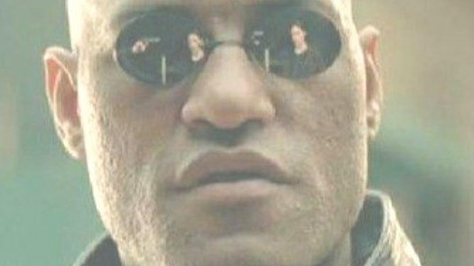
Warner Bros. / The Matrix (1999)
The Matrix: Resurrections and the Goliath in the Room
The Matrix Resurrections arrived in 2021 to a rumble of accusations and disappointment: cash-grab! feel-good romance! dumbed down! Neo and Trinity flying off into the sunset together? In The Matrix‽
The discussion since has oscillated from 'loved it' to 'hated it,' filtered through each viewer's relationship with the beloved franchise. Viewers debating an on-screen story that sometimes winked at them directly (Sati's knowing glance) and sometimes achingly obvious (Neo yearning for Trinity in the coffee shop). There were also hints at something darker: Neo trapped in a recursive nightmare, reliving his unconscious trauma by turning it into a video game.
And then came the big reveal: The new Matrix needs both Neo and Trinity (it always has) but especially needs them to suffer. This movie has been a deep well for lively discussion and speculation for years.
What if I told you...this discourse is missing crucial context?
In early 1999, Warner Brothers commissioned Neil Gaiman to write "Goliath" for the original Matrix film's promotional website. Published just before the film's release, it later appeared in The Matrix Comics and Gaiman's anthology Fragile Things, yet it's rare to see "Goliath" mentioned in discussions of Resurrections.
"Goliath" introduces a much darker subtext for our plugged-in again heroes.
In "Goliath," the unnamed protagonist is a genetically engineered giant who discovers the truth about the Matrix when an alien attack damages the system. He's recruited by the Machines to pilot a suicide mission: destroy the alien ship threatening Earth. He succeeds. But there's no way home. The ship wasn't designed for return; he has less than an hour of air left, orbiting the moon in what he describes as "a flying teacup."
So, he makes a bargain Laika could never voice: "I saved all your lives. Can you plug me back into the Matrix?"
The Machines grant his request. Sharp pain at the base of his skull, then fifteen years of subjective time, a full life with his wife Susan, running a computer shop, raising a son. All of it happening in his final twenty minutes as his body dies in space.
His last words: "They may be heartless, unfeeling, computerized bastards, leeching off the minds of what's left of humanity. But I can't help feeling grateful to them. I'll die soon. But the last twenty minutes have been the best years of my life."
The Machines understood what he wanted most. And they gave it to him as a reward for his service.
[You can read "Goliath" here: https://web.archive.org/web/20031203034621/http://whatisthematrix.warnerbros.com/cmp/neil_g.html]
Now consider The Matrix: Resurrections.
Our Neo and Trin have again unplugged through improbable feats of derring-do! Joyfully reunited and ready to tear it all down. With help from their new friends and the power of love (and lots of explosions), they conquer the Matrix. They kick The Analyst's butt!
The Matrix now belongs to them. They can make it whatever they want - flying through the sky hand-in-hand, unstoppable, free. It's satisfying, beautiful, perfect. It's what we all wanted. Right?
Goliath: "The last twenty minutes have been the best years of my life."
The Analyst's Matrix ran on Neo and Trinity's proximity for sixty years, but even enhanced human batteries wear out eventually.
Neo and Trinity fought. They escaped. They won.
They came to the end of their service life.
They didn't destroy the Machines; they were rewarded like good doggies. They are no longer useful, but their service is recognized. Like the pilot in "Goliath," the Machines threw them a bone and they got to live out their lives in happiness.
This is their Goliath moment. Somewhere, their aging bodies are failing. What we're watching, as they fly off into the sunset, is their final twenty minutes.
The best years of their lives.
The Machines are all around us.
Am I in the best years of my life?

